

UPF – Gestió de projectes
GP2526 Project Work Plan
Aigua Clara

Document Control Information

Settings | Value
Document Title: | Project Work Plan
Project Title: | Aigua Clara
Team Number: | 202.A
Project Owner: | Aigües de Barcelona (AB), Jordi Mora
Project Core Team: | Maria Beili Mena Dorado, Alex Fernández de Alarcon, Sergi Rodríguez, Pol Serrat, Ferran Sordé i Martí Vilaró

Revision | Date | Created by | Short Description of Changes
v0.1 | 7/oct/25 | Pol Serrat | Initiation: 2.2 Section and PM Branch
v1.0 | 15/oct/25 | Alex Fernández de Alarcon | Iteration 1: First Full Version of the PWP.

The latest version of this controlled document is stored in Google Drive\GP2025-26\Subject global documents\Project methodology and templates\

- Introduction
  - Project summary
Advanced data analysis techniques offer new opportunities to understand and characterize water consumption patterns. In this project we will develop a model capable of detecting anomalous consumption based on real data from Aigües de Barcelona remote reading. The implementation of this solution will significantly improve the detection of situations that exceed normality, facilitating a more efficient management of the service and promoting a more responsible use of hydraulic resources. This approach will allow us to identify irregularities such as leaks, technical malfunctions, or unexpected behavioral changes in consumption at an early stage. By integrating artificial intelligence and/or statistical learning methods, the model will continuously adapt to new data, increasing its precision over time. The results obtained can be used to educate among users and institutions about sustainable water management. This project aims to combine technology, environmental responsibility, and innovation to contribute to a smarter and more efficient urban water system.
  - Success Criteria and Critical Success Factors
Success Criteria
The objective is to create a technological solution that allows for the automatic detection of anomalies in user consumption to prevent and find unusual patterns such as leaks. Success is measured based on whether the result obtained for our service coincides with a real case of anomalous consumption and whether this can be detected in advance. The SMART objectives are the following:
- Project objectives: meet all the milestones of the work plan within the established deadlines.
- Product objectives: achieve a minimum accuracy of 75% in the detection of anomalies in the analyzed data.
- Business objectives: demonstrate the technical feasibility and social value of the project to Aigües de Barcelona, ​​highlighting its positive impact on sustainability and efficiency.
Basically, transform the environment and consumption of people in the metropolitan area of ​​Barcelona by improving management and promoting responsible consumption.

Critical Success Factors

In order to successfully complete the project, we need the involvement of all stakeholders, good data quality, dedication from team members in the development of the project and having clear Statements and outs from the team and the mentor. It will also be necessary for team members to have the necessary technical knowledge to develop the alert system.

  - Project Stakeholders
The main stakeholders involved in the project are the Project Owner (PO): Jordi Mora representing Aigües de Barcelona, Business Manager (BM): mentor from Aigües Barcelona, Solution Providers (SP): Project evaluators (teachers), Team Representative (TR): Maria Beili, Project Manager (PM): Martí Villaró, Project Core Team (PCT): 202.A team members, Project Steering Committee (PSC): PO, SP, BM, PM and Business Implementation Group (BIG): Aigües Barcelona users and investors. Full detail of the project stakeholders can be found in the document Team202A.ProjectStakeholderMatrix.vx.y

  - Project Constraints / Assumptions
We have identified some initial assumptions and constraints, which could be expanded as we move forward doing the project.
Assumptions:
1. The given data are correct, complete and representative. They have been carefully checked to ensure reliability and consistency, so all analyses and decisions can be based on facts. If any updates or corrections are needed in the future, they will be reviewed and shared with the team.
2. AB will maintain an active communication and participation with the teams. This includes participating in several meetings, providing feedback, and supporting coordination between different areas. AB will also make sure that everyone stays informed about progress, upcoming tasks, and any important project developments.
3. All team members will be equally involved in each phase of the project.

Constraints:
1. Time limit: We must stick to the schedule set by AB and follow their time line.
2. Personal limitations: We are only six people to carry out the entire project, we should think twice before setting any objective, see if we are capable of achieving it. We should make sure that each goal is realistic and achievable within our capacities, distributing tasks efficiently to maintain a balanced workload.
3. Resources limit: We have a limited amount of resources provided by the University and AB such as technological tools, advice or personal experience inside AB and from which point of view we should aim our project, therefore, we need to use these resources wisely and focus our project in a direction that makes the best use of the available support and guidance.
4. We don’t have a financial budget for the development of the project.

- PRODUCT SCOPE
Develop a functional prototype capable of detecting patterns of anomalies in the water consumption of Aigües de Barcelona users using Machine Learning algorithms.

  - Requirements
ID | Name  Short name of the requirement | Description | Category  Requested by | Deliverable ID
Rq1 | Data Collection and Cleaning | The system must be capable of processing and cleaning large datasets of water consumption | Functional Requirement - Aigües de Barcelona | 1.3.1.1
Rq2 | Anomaly Detection Model | Develop and train a Machine Learning model able to identify anomalies in the consumption patterns. | Functional Requirement - Aigües de Barcelona | 1.3.1.3
Rq3 | Dashboard for Visualization | Provide a simple dashboard or visualization tool that displays identified anomalies. | Feature / Functional Requirement - Aigües de Barcelona | 1.3.1.5
Rq4 | Documentation | Deliver all project documentation for the usage of the project | Support Requirement - UPF(teachers) | 1.4.1

  - Work Breakdown Structure
Work Breakdown
1.0 |  | Aigua Clara
1.1 |  | Documents d’Iniciació
1.1.1 |  |  | Project Charter
1.1.2 |  |  | Registre a AB Data Challenge
1.2 |  | Documents de Planificació
1.2.1 |  |  | Project Work Plan
1.2.2 |  |  | Project Stakeholder Matrix
1.3 |  | Documents d’Execució
1.3.1 |  |  | Model Development and Implementation
1.3.1.1 |  |  |  | Data collection and Implementation
1.3.1.2 |  |  |  | Exploratory data analysis
1.3.1.3 |  |  |  | Model selection and training
1.3.1.4 |  |  |  | Evaluation and improvement
1.3.1.5 |  |  |  | Model integration (visualization)
1.4 |  | Documents de Finalització
1.4.1 |  |  | Project End Report
1.5 |  | Documents de Monitoratge i Control
1.5.1 |  |  | Project Logs
1.5.1.1 |  |  |  | Change Log
1.5.1.2 |  |  |  | Risk Log
1.5.1.3 |  |  |  | Issue Log
1.5.2 |  |  | Project Work Plan (updates)
1.5.3 |  |  | Project Phase-Exit Review Checklist
1.6 |  | Participació al Concurs d’Aigües de Barcelona
1.6.1 |  |  | Inscripció al Concurs
1.6.1.1 |  |  |  | Registre de Participants Individual
1.6.1.2 |  |  |  | Registre del Projecte Grupal
1.6.2 |  |  | Entrega del Projecte Final
1.6.3 |  |  | Presentació del Projecte Final

Work Breakdown Component Description
Delierable 0
Establish the project foundation, define objectives and complete initiation documentation (Project Charter and Management Branch).
Estimate: 4 hours
Responsible: Project Representative
Due date: 12/10/2025

Activity 0
Develop the Project Charter, the project scope, objectives and stakeholders. Create the Project Management Branch.
Estimate: 4 hour
Responsible: Project Representative
Due date: 12/10/2025
Deliverable 1
Develop and baseline of the Project Work Plan and Stakeholder Matrix for Aigua Clara.
Estimate: 6 hour
Responsible: Project Representative
Due date: 19/10/2025

Activity 1
Define the Work Breakdown Structure and complete the Stakeholder Matrix.
Estimate: 6 hours
Responsible: Project Representative
Due date: 19/10/2025

Deliverable 2
Have a cleaned and processed dataset ready for anomaly detection modeling.
Estimate: 5 days
Responsible: Project Representative
Due date: 31/10/2025
Activity 2
Collect, clean, and preprocess consumption data from Aigües de Barcelona.
Estimate: 5days
Responsible: Project Representative
Due date: 31/10/2025
Deliverable 3
An operational Machine Learning model capable of detecting anomalies in consumption patterns.
Estimate: 7 days
Responsible: Project Representative
Due date: 16/11/2025
Activity 3
Train various algorithms, evaluate their model performance and select the optimal model..
Estimate: 7 days
Responsible: Project Representative
Due date: 16/11/2025
Deliverable 4
A functional dashboard visualizing anomalies and consumption behavior for Aigües de Barcelona.
Estimate: 5 days
Responsible: Project Representative
Due date: 23/11/2025
Activity 4
Develop a visualization tool that displays anomaly alerts and consumption trends.
Estimate: 5 days
Responsible: Project Representative
Due date: 23/11/2025
Deliverable 5
Final project documentation and presentation for the Aigües de Barcelona Challenge.
Estimate: 6 hour
Responsible: Project Representative
Due date: 30/11/2025
Activity 5
Prepare and deliver the final Challenge Report and finalize the presentation slides.
Estimate: 6 hour
Responsible: Project Representative
Due date: 30/11/2025
Deliverable 6
Project closure report including evaluation and performance assessment.
Estimate: 4 hour
Responsible: Project Representative
Due date: 7/12/2025
Activity 6
Write the Project End Report, summarizing the project’s outcomes.
Estimate: 4 hour
Responsible: Project Representative
Due date: 7/12/2025

PROJECT MANAGEMENT BRANCH (CAN BE EXTENDED)
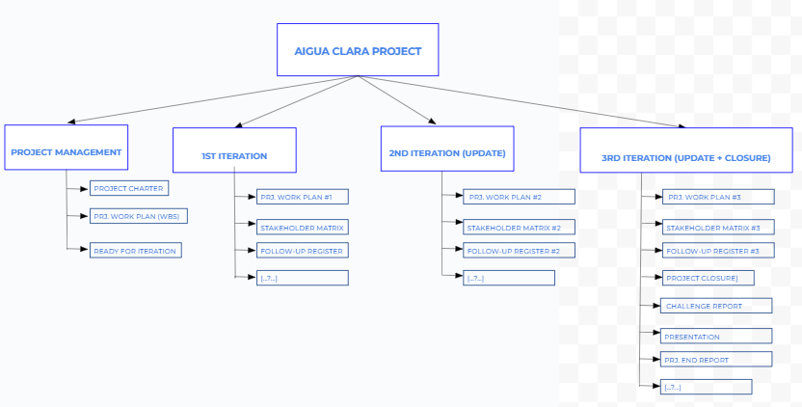

- Roles & responsibilities (optional)
<If the team has decided to change the RASCI from the Project Handbook describe them. The team can decide to add a project manager role. Changes can only apply to the PM, REP and the PCT.>

- Communications Management
Every Sunday we will meet via Zoom to do a review about the current status of the project, how and when we do the remaining work, new changes to take into consideration, modifications, etc. We stay in touch via email and phone messages to communicate updates at any time.
- Configuration Management
To work in real time and together, we have created a shared directory on Google Drive, with all the needed documents. Later on, we may create a Github repository as well.

